MY SQL QUERIES
Dominos Pizzas Store Analysis

-- What is the total Number of unique order placed so far ?
select count(*) from orders;
select count(distinct(order_id)) unique_order from orders;
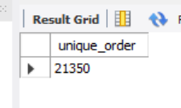
-- How has this order volume changed month-over-month year-over-year?
with monthly_orders as (
select date_format(order_date,'%Y-%m-01') as months ,
count(order_id) order_count
from orders
group by months
)
select months , order_count ,
lag(order_count) over (order by months) as pev_months,
(order_count - lag(order_count) over (order by months)) as order_diff,
round(100.0 *(order_count - lag(order_count) over (order by months))/ nullif(lag(order_count) over(order by months),0),2) mom_growth_pct
from monthly_orders
order by months;
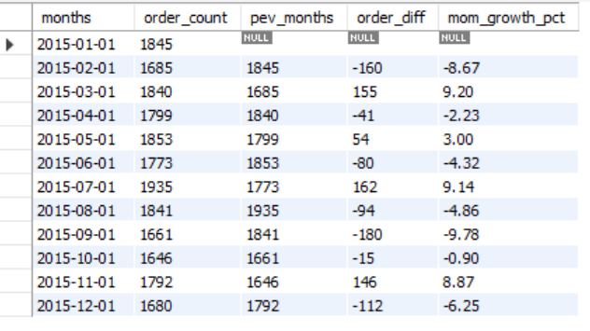
with yearly_orders as (
select date_format(order_date,'%Y-01-01') as years,
count(order_id) order_count
from orders
group by years
)
select years,order_count,
lag(order_count) over (order by years) as pev_count,
round(100.0*(order_count - lag(order_count) over (order by years))/nullif(lag(order_count) over (order by years),0),2) yoy_growth_pct
from yearly_orders
order by years;


-- can we identify peak and off-peak ordering days ?
with days_orders as(
select DAYNAME(order_date) AS weekday,
COUNT(order_id) AS orders
FROM orders
GROUP BY weekday
)
select weekday,orders,
case
when orders= (select max(orders) from days_orders) then 'Peak Day'
when orders=(select min(orders) from days_orders ) then 'off-Peak Day'
else 'Normal Day'
end as Trends
from days_orders
order by orders desc;
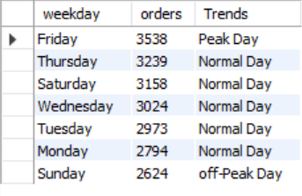
-- How do order volumes vary by day of the weak (e.g weekend vs weekdays)?
with days_order as (
select dayname(order_date) as days_name,
count(order_id) order_count
from orders
group by days_name
)
select days_name,order_count,
lag(order_count) over (order by order_count) as pev_days_orders,
round(100.0*(order_count - lag(order_count) over (order by order_count))/ nullif(lag(order_count) over (order by order_count),0),2) dod_perct
from days_order
order by order_count;
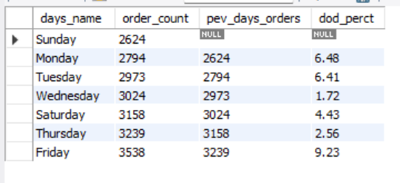
-- what is the avg number of order per cusotmer?
WITH orders_per_customer AS (
SELECT o.custid, COUNT(*) AS total_orders
FROM orders o
GROUP BY o.custid
)
SELECT AVG(total_orders) AS avg_orders_per_customer
FROM orders_per_customer;
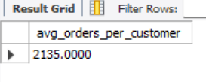
-- who are our top repeat customer driving the order volumnes?
select c.custid ,c.first_name,c.last_name , count(distinct o.order_id) as frequency
from orders o join customers c
on o.custid=c.custid
group by c.custid,c.first_name,c.last_name
order by frequency desc;
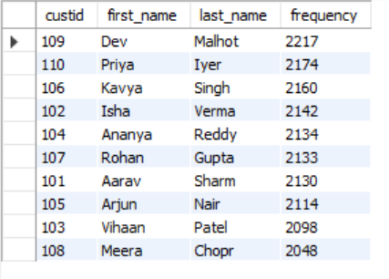
-- can you also project the expercted order growth trend bases on historical data?
-- cumulative trends
SELECT order_date,daily_orders,
SUM(daily_orders) OVER (ORDER BY order_date) AS cumulative_orders
FROM (
SELECT order_date, COUNT(DISTINCT order_id) AS daily_orders
FROM orders
GROUP BY order_date
) AS t
ORDER BY order_date;

--we need to report monthly revenue to management.
can you calculate the total revenue generated from all pizza sales.
select date_format(o.order_date,'%Y-%m-01') as months ,
round(sum(p.price*od.quantity),2) as Total_revenue from order_details od join pizzas p
on od.pizza_id=p.pizza_id
join orders o on od.order_id=o.order_id
group by months
order by months;

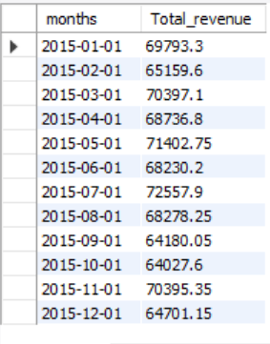
-- Highest-Priced Pizza
select p.pizza_id,pt.name,
pt.category,p.size,
concat('$',p.price) from pizzas p join pizza_types pt
on p.pizza_type_id=pt.pizza_type_id
order by p.price desc
limit 1;

-- MOST COMMON PIZZA SIZE ORDERED
select p.size ,count(*) total_order from order_details od join pizzas p
on od.pizza_id = p.pizza_id
group by p.size
order by total_order desc
limit 1;
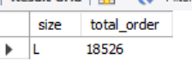

-- TOP 5 MOST ORDERED PIZZA TYPES
select p.pizza_id,pt.name,pt.category ,sum(od.quantity) total_quantity from order_details od join pizzas p
on od.pizza_id = p.pizza_id
join pizza_types pt on p.pizza_type_id=pt.pizza_type_id
group by p.pizza_id
order by total_quantity desc
limit 5;
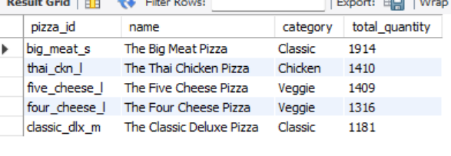

-- TOTAL QUANTITY BY PIZZA CATEGORY
select pt.category,sum(od.quantity) total_order
from order_details od join pizzas p on od.pizza_id=p.pizza_id
join pizza_types pt on p.pizza_type_id=pt.pizza_type_id
group by pt.category
order by total_order desc;
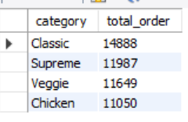

-- ORDER BY HOUR OF THE DAY
SELECT DATE_FORMAT(STR_TO_DATE(order_time, '%H:%i:%s'), '%H:00') hour_slot,
COUNT(*) AS total_orders
FROM orders
GROUP BY hour_slot
ORDER BY hour_slot;
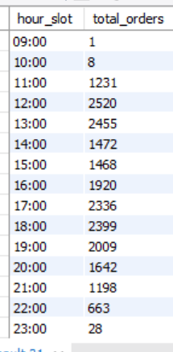

-- CATEGORY-WISE PIZZA DISTRIBUTION
with revenue as (
select sum(od.quantity*p.price) as total_revenue from order_details od join pizzas p
on od.pizza_id=p.pizza_id
)
select pt.category,sum(od.quantity) total_quantity,
round(sum(od.quantity*p.price),2) cate_total_revenue ,
concat(round((sum(od.quantity*p.price)/max(r.total_revenue))*100,2),'%') as percenatge_share
from order_details od join pizzas p
on od.pizza_id=p.pizza_id
join pizza_types pt on p.pizza_type_id=pt.pizza_type_id
CROSS JOIN revenue r
group by pt.category
order by cate_total_revenue desc;
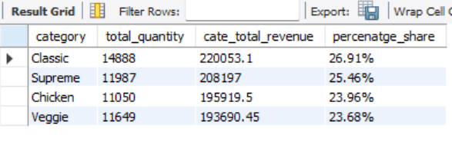

-- AVERAGE PIZZAS ORDERES PER DAY
select round(avg(daily_total),0) as avg_pizzas_per_day
from ( select o.order_date,sum(od.quantity) as daily_total
from order_details od join orders o on od.order_id=o.order_id
group by o.order_date
)t;
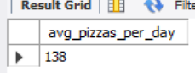

-- TOP 3 PIZZAS BY REVENUE
WITH pizza_revenue as(
select pt.name,round(sum(od.quantity*p.price),0) total_revenue ,
rank() over (order by round(sum(od.quantity*p.price),0) desc) as rnk
from order_details od join pizzas p on od.pizza_id=p.pizza_id
join pizza_types pt on p.pizza_type_id=pt.pizza_type_id
group by pt.name
)
select name,total_revenue
from pizza_revenue
where rnk <=3;
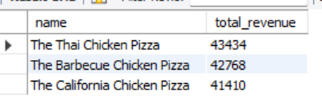

-- revenue of top 3 pizza by size also
select od.pizza_id,round(sum(od.quantity*p.price),0) total_revenue from order_details od join pizzas p
on od.pizza_id=p.pizza_id
join pizza_types pt on p.pizza_type_id=pt.pizza_type_id
group by od.pizza_id
order by total_revenue desc
limit 3;
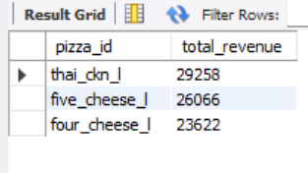

-- REVENUE CONTRIBUTION PER PIZZA
select pt.name,round(sum(od.quantity*p.price),0) pizza_revenue,
concat(round(100*(sum(od.quantity*p.price)/sum(sum(od.quantity*p.price))over()),2),'%') as pct_contribution
from order_details od join pizzas p on od.pizza_id=p.pizza_id
join pizza_types pt on p.pizza_type_id=pt.pizza_type_id
group by pt.name
order by pct_contribution desc;
;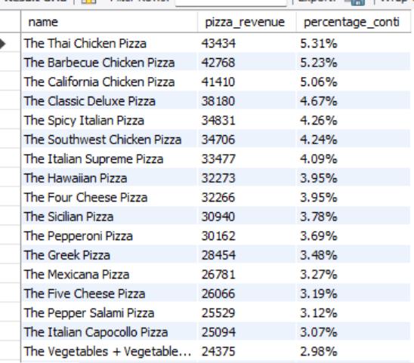 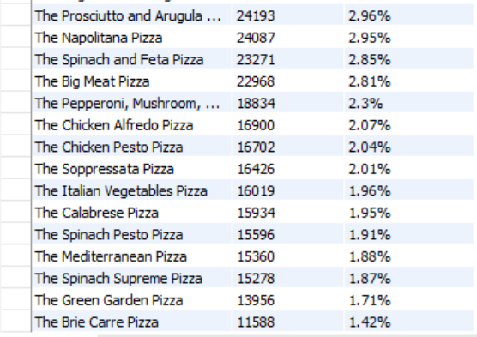

-- CUMULATIVE REVENUE OVER TIME
select order_date,daily_revenue,
sum(daily_revenue) over (order by order_date) as culumative_revenue
from
(
select o.order_date,
round(sum(od.quantity*p.price),0) as daily_revenue
from orders o join order_details od on o.order_id=od.order_id
join pizzas p on od.pizza_id=p.pizza_id
group by o.order_date
) t;
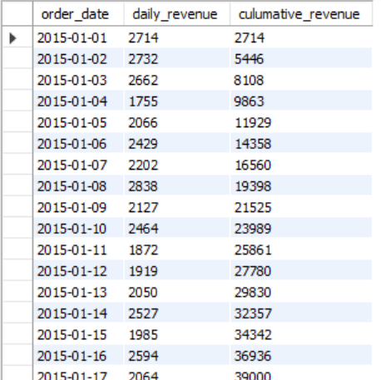

-- TOP 3 PIZZAS BY CATEGORY (REVENUE_BASED)
with cat_rank as (
select pt.category,pt.name,sum(p.price*od.quantity) as revenue,
rank() over (partition by pt.category order by sum(p.price*od.quantity) desc )as rnk
from order_details od join pizzas p on od.pizza_id=p.pizza_id
join pizza_types pt on p.pizza_type_id=pt.pizza_type_id
group by pt.category,pt.name
)
select category,name,revenue
from cat_rank
where rnk <=3;
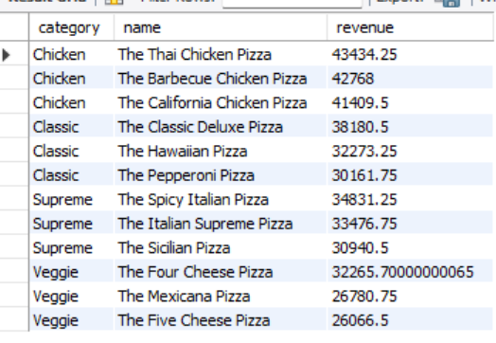

-- TOP 10 CUSTOMER BY SPENDING
select c.custid,c.first_name,c.last_name ,round(sum(od.quantity*p.price),2) total_spend
from customers c join orders o on c.custid=o.custid
join order_details od on o.order_id=od.order_id
join pizzas p on od.pizza_id=p.pizza_id
group by c.custid,c.first_name,c.last_name
order by total_spend desc
limit 10;
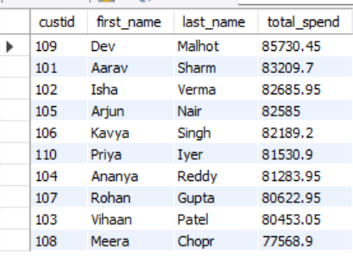

-- ORDER BY WEEKDAYS
select dayname(order_date) as Week_day ,
count(order_id) as count_order
from orders
group by week_day
order by count_order desc
;
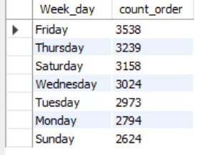

-- AVG ORDER SIZE
select round(avg(per_order_count),0) as order_size
from (
select od.order_id,sum(od.quantity) as per_order_count
from order_details od
group by od.order_id
) t;
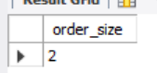

-- SEASONAL TRENDS
select month(order_date) months, count(*) as total_orders
from orders
group by months
order by months;
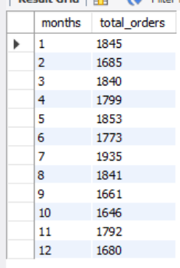

-- REVENUE BY PIZZA SIZE
select p.size,round(sum(od.quantity*p.price),2) revenue
from order_details od join pizzas p on od.pizza_id=p.pizza_id
group by p.size
order by revenue desc;
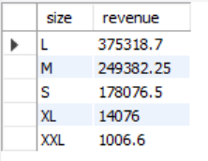

-- CUSTOMER SEGMENTATION
/*
do our high-value customer prefer premium pizza or
regular pizza? we want to personalized marketing.
*/
with cust_spend as(
select c.custid,sum(od.quantity*p.price) total_spend
from customers c join orders o on c.custid=o.custid
join order_details od on o.order_id=od.order_id
join pizzas p on od.pizza_id=p.pizza_id
group by c.custid
)
select
case
when total_spend > 40000 then 'High-value'
else 'Regual'
end as segment,
count(*) as customer_count
from cust_spend
group by segment;
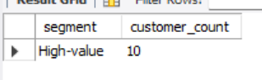

-- REPEAT CUSTOMER RATE
with cust_order as (
select custid,count(*) total_cust_count
from orders
group by custid
)
select
round(100.0*sum(case when total_cust_count>1 then 1 else 0 end )/count(*),2)as repeat_rate
from cust_order;
